**Web Programing Project**

**Generation Z Barber**

Mohammed Hassan Abdo 18107233

Ahmed Tarek 18207547

Bassel Amr 18107401

Antonious Michel 18107295

Web site name: Generation Z Barber

Description:

In our website customer can buy products and tools like shaves, clippers, shears, after shave lotion, hair dryers and combs. Also, the customer can book online for his place in the barber shop, He can book the hairstyles that he wants from the magazines and he can also book for the full service like washing, making hot towel, cold towel and etc. …. The customer can also request for haircut from home and the barber will go to his home and make the haircut to the customer. The customer can cancel the request or booking in any time before the barber come to him and before the booking in 15 mints. The customer can pay with credit card or with cash.

Database:

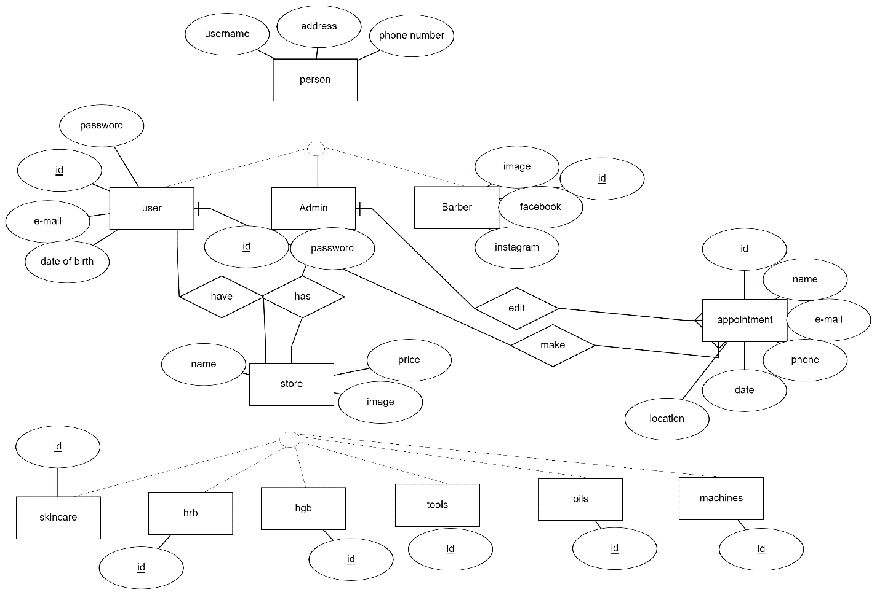

Use case diagram:

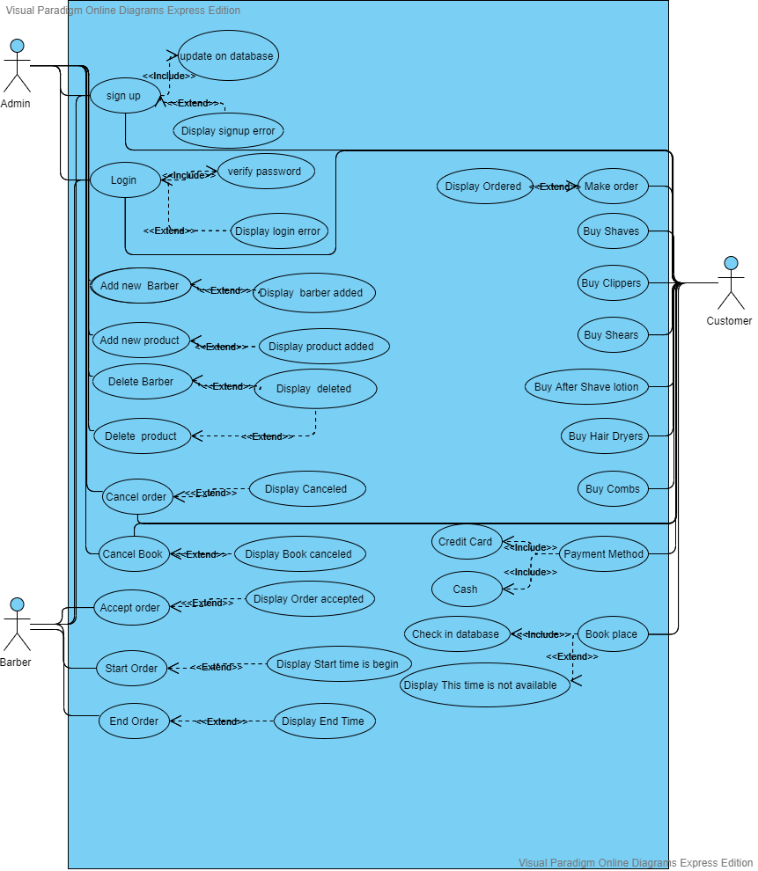

Functional:

1. Sign up: take name – password - address – age – phone number – location from customer, Manager and Barber and updated in database.
2. Login: take username – password -from customer and Manager and Barber and check it from database.
3. Add new Barber: Manager can use it to add new barber in Database.
4. Add new Product: Manager can use it to add new product in Database of website.
5. Delete Barber: Manager use it to delete barber from Database of website.
6. Delete product: Manager use it to delete product from database.
7. Cancel order: Manager, customer use it to cancel order but must use it within 10 min.
8. Cancel Book: Manager, customer use it to cancel Book.
9. Accept order: Barber use it to accept request from customer.
10. Start order; Barber use it to start time when he begins work.
11. End start: Barber use it to end order of customer.
12. Make order: Customer use it to make a request to barber.
13. Buy: customer use it to buy products Like:

Shaves, Clippers, shears, After shave lotion.

1. Book: customer use it to book place in Barber shop.
2. Payment Method: customer use it to choose what way want to pay he can use credit card or Cash.

Main pages:

1. Sign up / Login.
2. Product.
3. order.
4. Book place.
5. Contact us.

User Manual of website

Login as Admin:

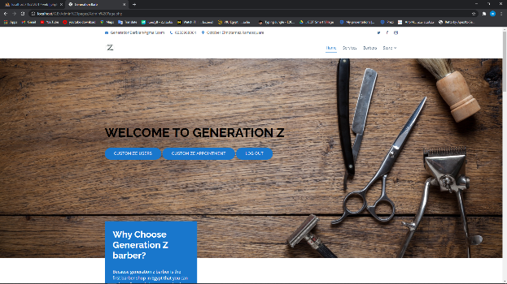

Customize user:

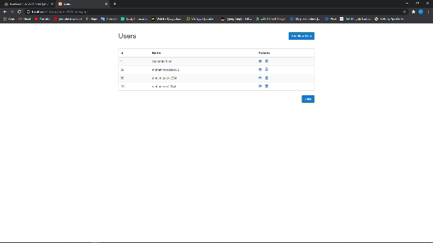

Read user info:

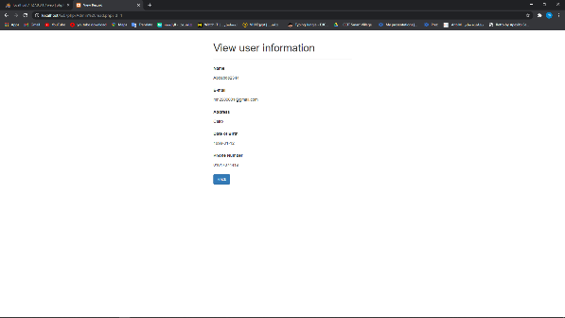

Delete user:

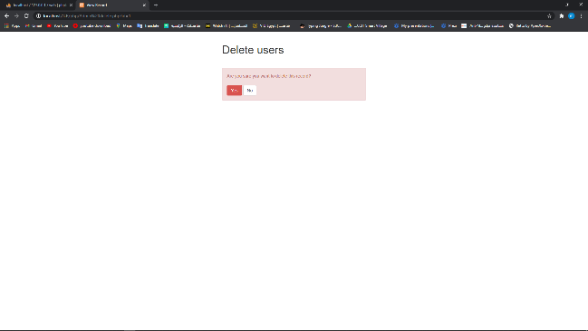

Add new user:

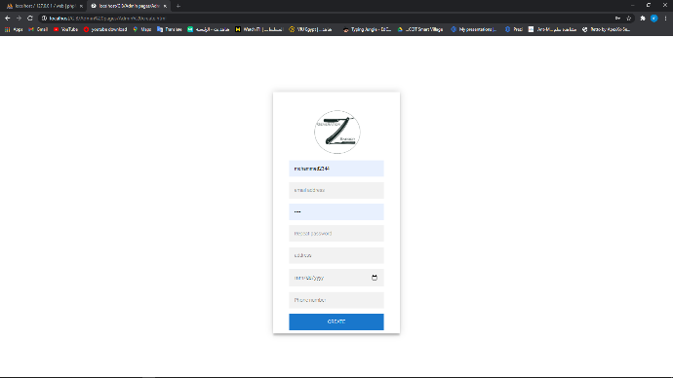

Customize Appointment:

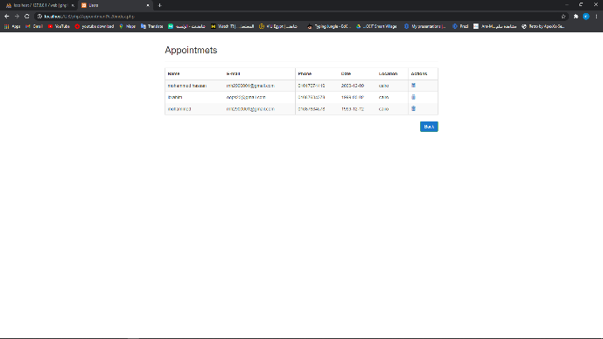

Delete Appointment:

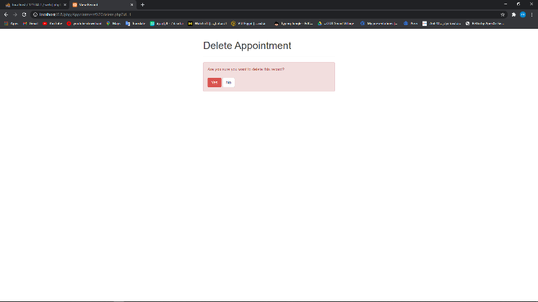

Customize Barber:

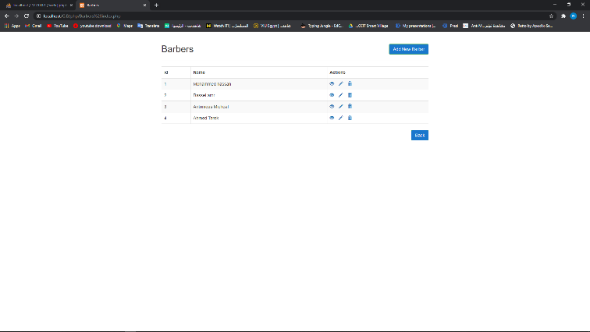

Delete Barber:

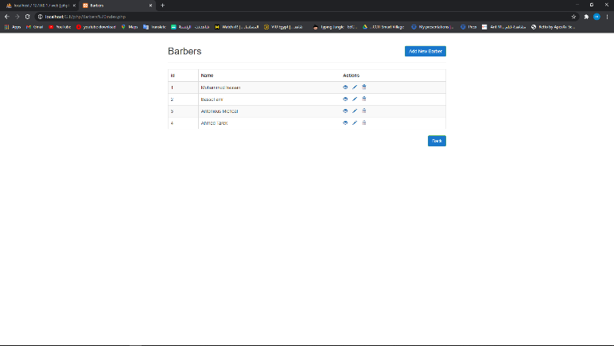

Update Barber:

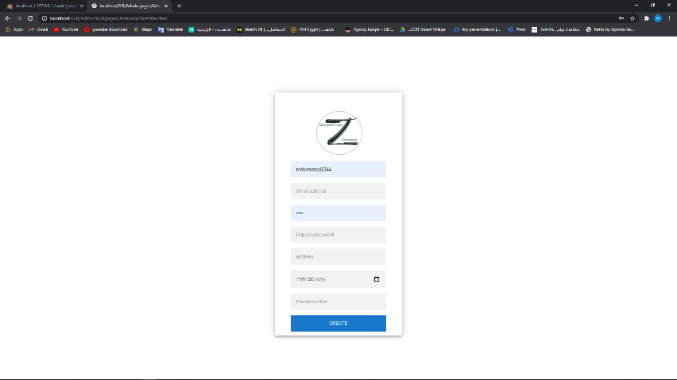

Add Barber:

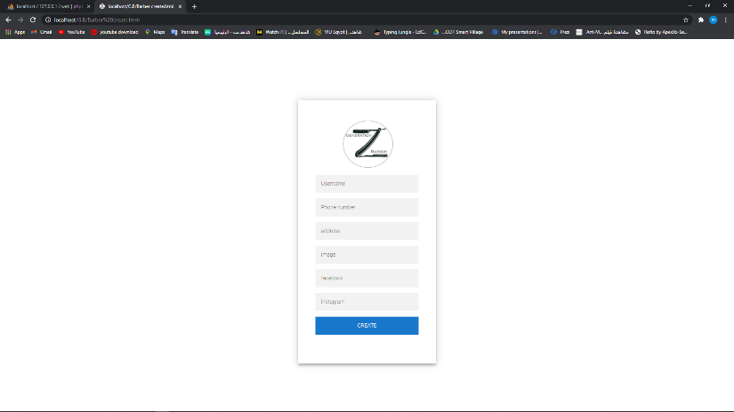

Store:

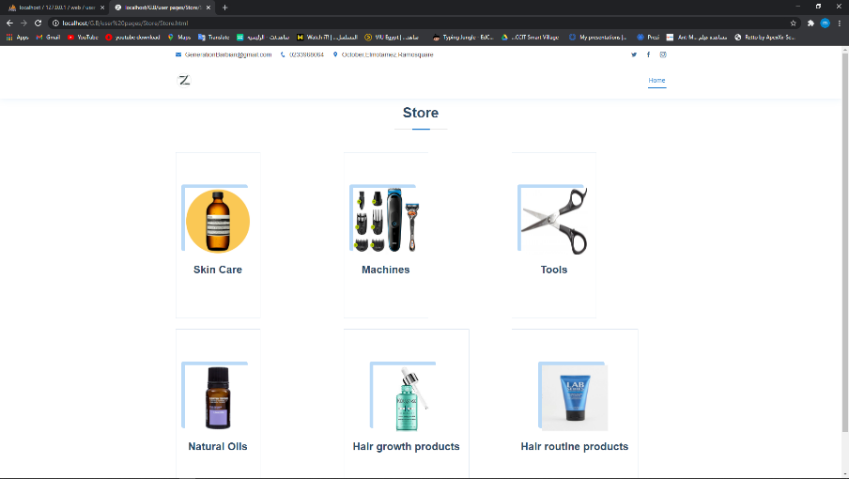

Ex: SkinCare:

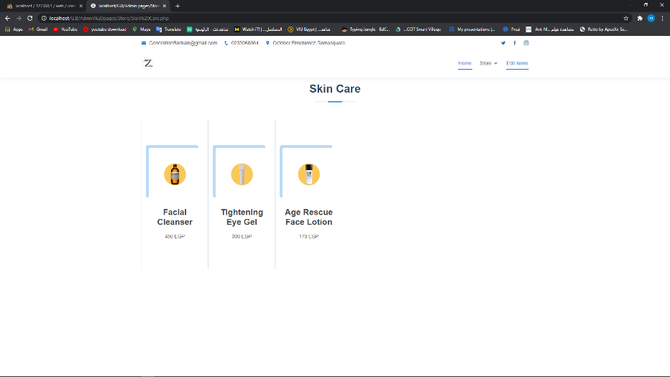

Edit items:

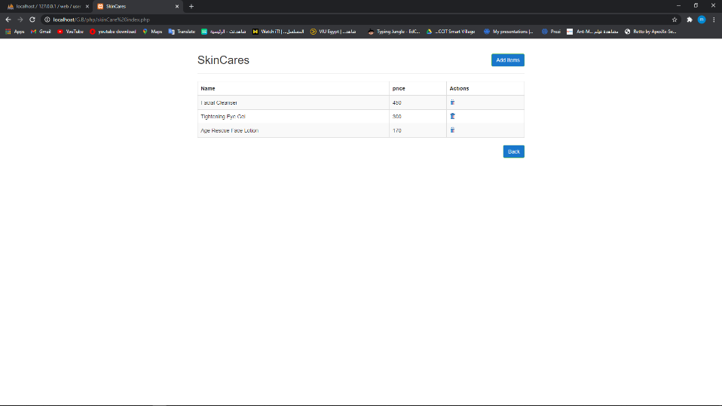

Delete item:

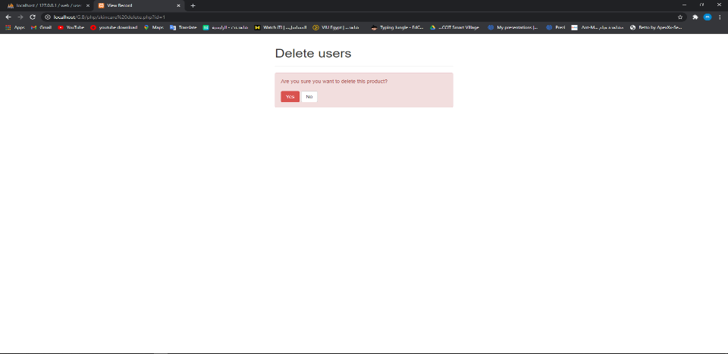

Add item:

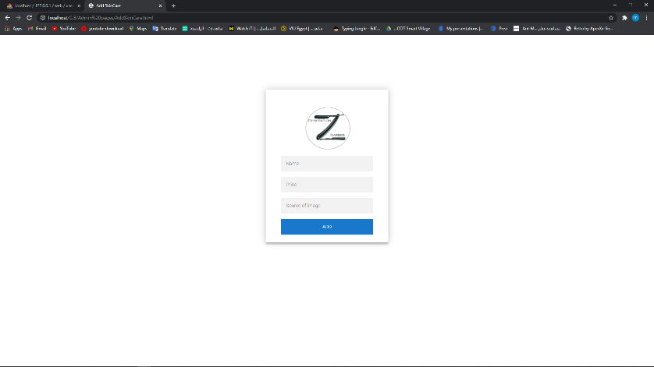

Login as User:   
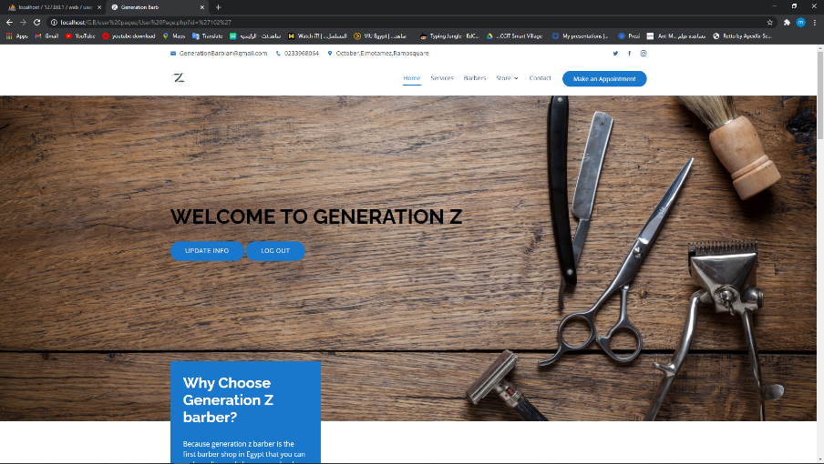

Update info:

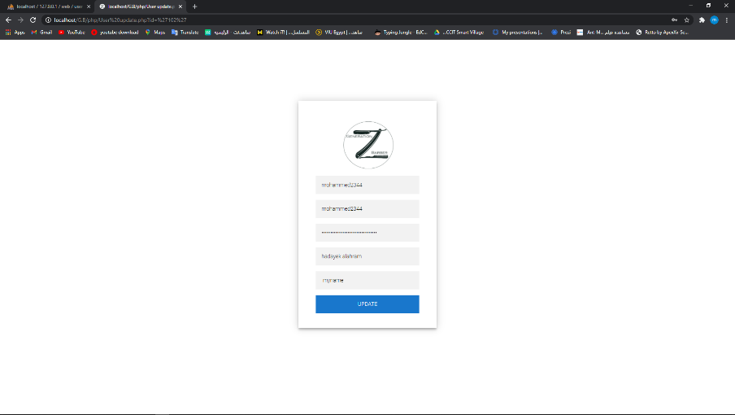

Make Appointment:

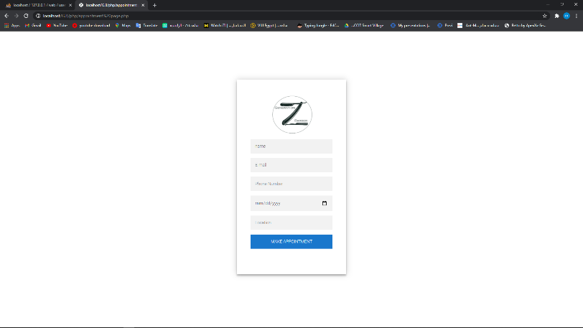

Store:

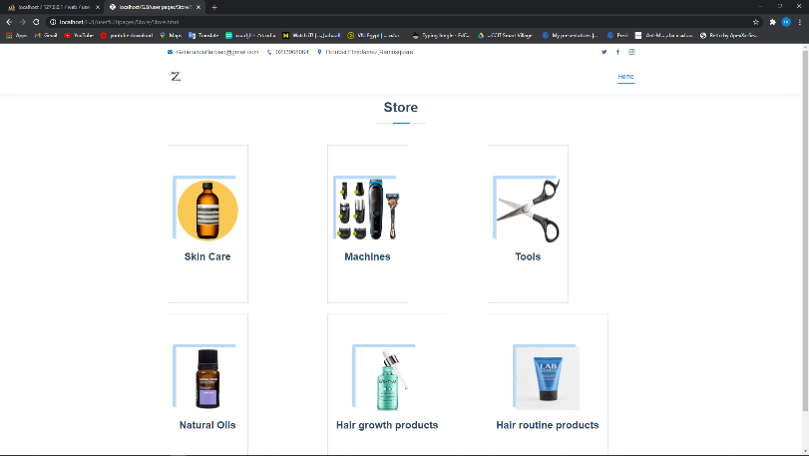

Ex:SkinCare

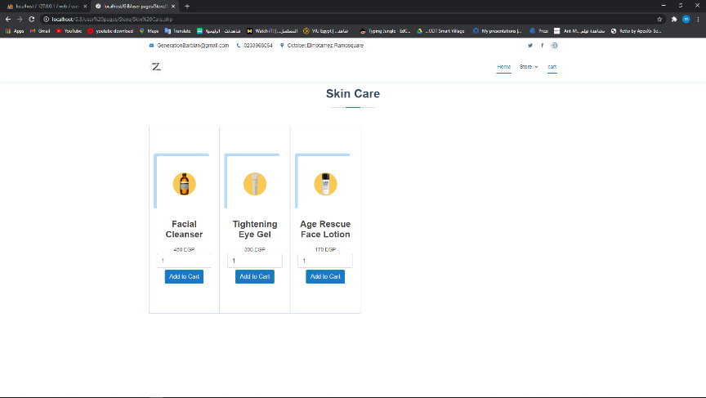

Add to cart:

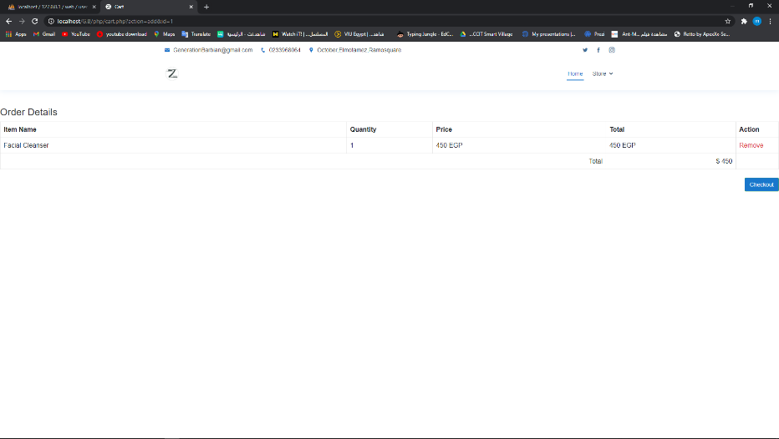

Checkout:

